PRN - 240340128031

import pandas as pd

import numpy as np

from sklearn.preprocessing import StandardScaler

from sklearn.cluster import KMeans

from sklearn.datasets import load_iris

from sklearn.compose import make_column_transformer, make_column_selector

from sklearn.preprocessing import OneHotEncoder

from sklearn.ensemble import RandomForestClassifier

from sklearn.impute import SimpleImputer

from sklearn.model_selection import train_test_split, StratifiedKFold, GridSearchCV

from sklearn.metrics import log_loss, accuracy_score, confusion_matrix, silhouette_score, ConfusionMatrixDisplay

import matplotlib.pyplot as plt

Q1.

a

titanic = pd.read_csv("Titanic-Dataset.csv",index_col=0)

titanic

1_1

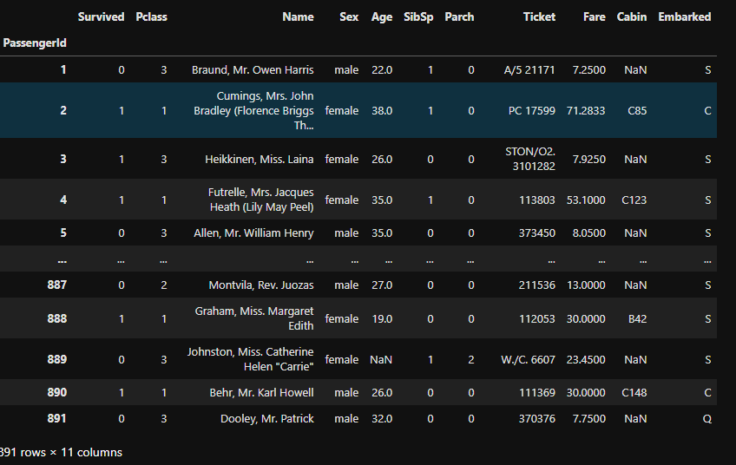

titanic.info()

1_2

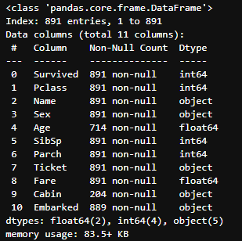

print(titanic['Sex'].value_counts())

print(titanic['SibSp'].value_counts())

print(titanic['Parch'].value_counts())

print(titanic['Embarked'].value_counts())

1_3

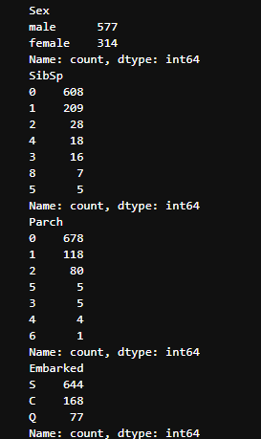

titanic['Sex_male'] = pd.get_dummies(titanic['Sex'],drop_first = True)

titanic.drop("Sex",axis=1,inplace=True)

titanic.head()

1_4

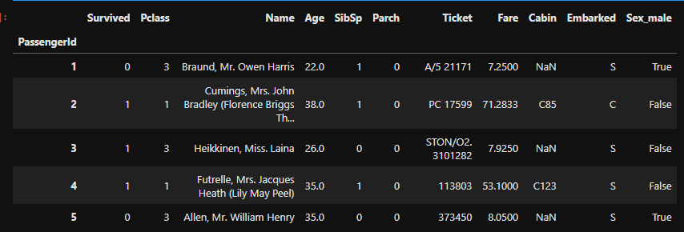

b

titanic.isna().sum()

1_5

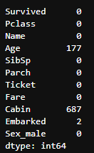

imp_mean = SimpleImputer(missing_values=np.nan, strategy='mean')

ct = make_column_transformer(("passthrough",make_column_selector(dtype_include = object)),

(imp_mean,make_column_selector(dtype_include = ["int64","float64"])),

verbose_feature_names_out=False).set_output(transform='pandas')

dum_np = ct.fit_transform(titanic)

dum_np

1_6

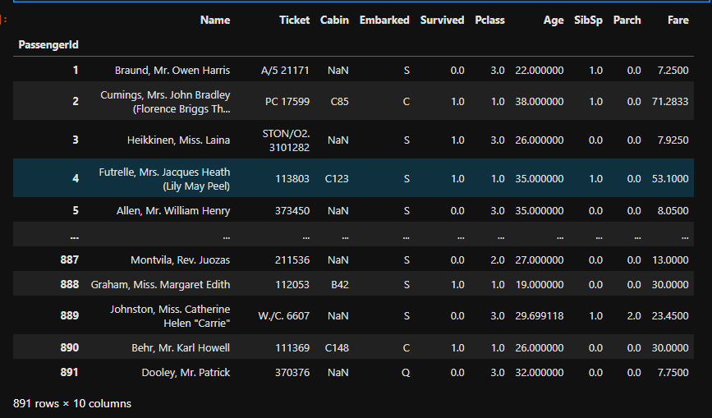

dum_np.isna().sum()

1_7

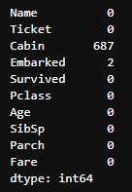

Q2

titanic = pd.read_csv("Titanic-Dataset.csv",index_col=0)

titanic

2_1

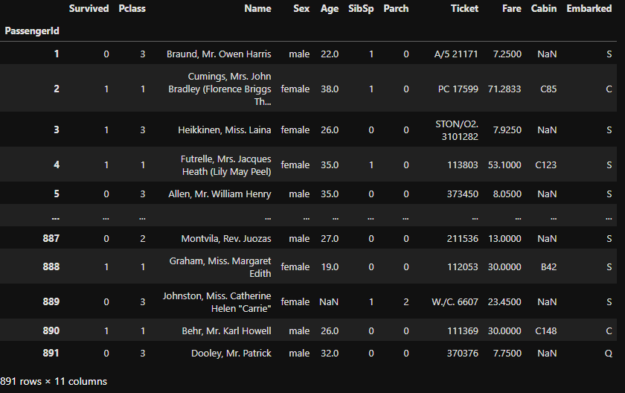

female_titanic = titanic[titanic['Sex']=='female']

female_titanic.drop(['Name','Ticket','Cabin'],inplace=True,axis=1)

female_titanic.info()

2_2

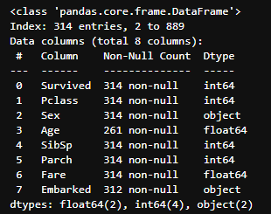

impute_age = SimpleImputer(strategy='mean').set_output(transform='pandas')

impute_embarked = SimpleImputer(strategy='most_frequent').set_output(transform='pandas')

ct = make_column_transformer((impute_age,['Age']),(impute_embarked,['Embarked']),remainder='passthrough',verbose_feature_names_out=False).set_output(transform='pandas')

titanic_fe = ct.fit_transform(female_titanic)

titanic_fe.info()

2_3

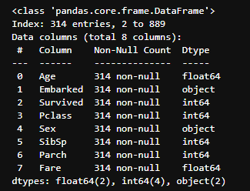

X = pd.get_dummies(titanic_fe.drop('Survived',axis=1),drop_first=True)

y = titanic_fe['Survived']

X_train,X_test,y_train,y_test = train_test_split(X, y, test_size=0.30, random_state=24, stratify=y)3

rf = RandomForestClassifier()

rf.fit(X_train,y_train)

y_pred = rf.predict(X_test)

print(accuracy_score(y_test,y_pred))

y_pred_prob = rf.predict_proba(X_test)

print(log_loss(y_test,y_pred_prob))

2_4



b

confusion_matrix(y_test,y_pred)

2_5



C

rf = RandomForestClassifier()

kfold = StratifiedKFold(n_splits=5,shuffle=True, random_state=24)

params = {'max_depth':[None,2,3],'min_samples_split':[2,10,15],'min_samples_leaf':[1,5,9]}

gcv = GridSearchCV(rf,param_grid=params,cv=kfold,scoring='neg_log_loss')

gcv.fit(X,y)

print(gcv.best_params_)

print(gcv.best_score_)

2_6



From comparing results, absolute value of neg loss after tuning (-0.414932) is closer to zero than log loss value (0.417944)without tuning. Hence it can be concluded that results have improved.

Q3

iris = load_iris()

df = pd.DataFrame(data = iris.data,columns=iris.feature_names)

df.info()

3_1

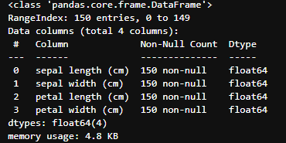

scaler = StandardScaler().set_output(transform='pandas')

iris_scaled = scaler.fit_transform(df)

Ks = np.arange(2,8)

scores = []

for i in Ks:

clust = KMeans(n_clusters=i,random_state=24,init='random')

clust.fit(iris_scaled)

scores.append(silhouette_score(iris_scaled, clust.labels_))

i_max = np.argmax(scores)

print("Best no. of clusters:", Ks[i_max])

print("Best Score:", scores[i_max])

3_2



plt.plot(Ks,scores)

plt.title("Number of Centroids vs silhouette score")

plt.xlabel('Number of Centroids')

plt.ylabel('silhouette score')

plt.show()

3_3

